Capstone Task Day 03
Name: Ibrahim Shnouda
Group: IoT701-A
Facilitator: Eng.Ehab Elsayed
------------------------------------------------------------------------------------------------------

Tasks:

1. $ sudo groupadd iot_team
$ sudo gpasswd -a ibrahim iot_team

2. $ sudo useradd dev
$ sudo gpasswd -a dev iot_team

3. $ sudo chown -R dev:iot_team /home/ibrahim/iot_logger
4. $ sudo chmod 755 logs
$ su - dev

5. $ sudo userdel dev

Screenshot:
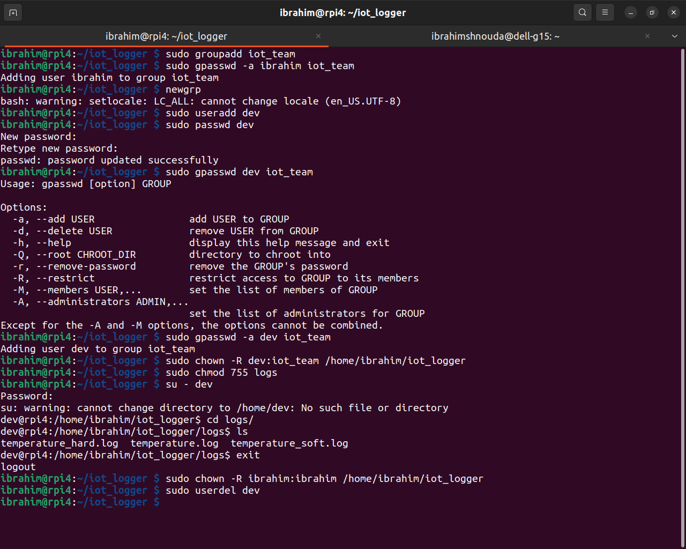

Open-Ended Questions:

1. chang permessions using (chmod) command followd by permission then by file or directory : chmod premession file

file permissions : rwx read, write, execute
permissions for owner(u) followed by groups (g) then others(o)
we can use the charecters mode or octal numbers mode
1.charchter mode ex: chmod u+x file.c
thts means access the owner to execute file.c
(+) for add premession, (-) for remove permission, etc..

2.numbers mode: to convert from (drwxr-xr-x) to be 755
ex: chmod 755 file.c

2.octal notation: to convert from (drwxr-xr-x) to be 755
ex: chmod 755 file.c

umask: to remove some permissions from defulat premissions
if defulat = rwxr-xr-x
octal notation = 755
umask = --- r-- r--
after rmoving = rwx r-- r--
umask value = 044
then bitwize them = 744

command: $umask 744

3.root user has all permissions (rwx) to all files, full control to the system
becouse this is dangerous
normall user restricted to their own home directory

